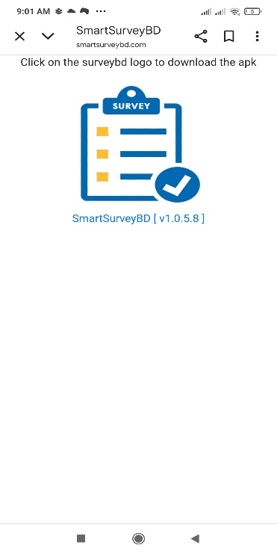
User Manual for SmartSurvey

- Write smartsurveybd.com/apk in your mobile/tab browser. You will
get below screen. Click on APK SmartSurvey to download the apk.
Android Emulator can also be downloaded from Android Emulator
(NOX) link for desktop. Android Emulator (NOX) is used to run the
SmartSurvey App in desktop and get the survey on it.

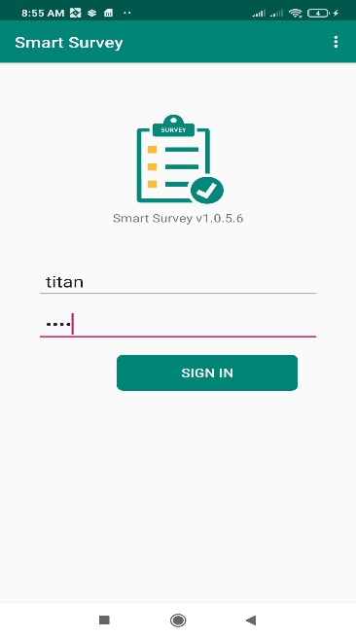

- Install the apk once it downloaded. After completing successful
installation you will get an icon “SmartSurvey” in your app list.
Click on the icon to start SmartSurvey app. Login page will be
appear.

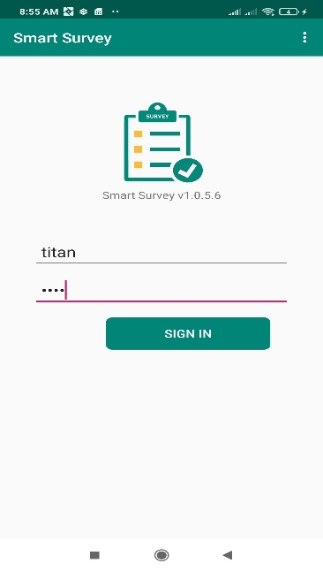

- Put User Id and Password in specific field and press login.
For first time, after successful login it will download the survey
assigned for that particular user. It will check the script version
if internet connectivity is available and update the script if required
for rest of the login.

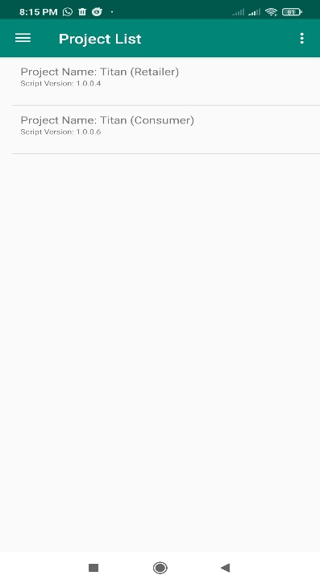
- Now you are in the home page of a survey. It will show the project
list with project name, script version. Click on the list Item to get a
project home page.

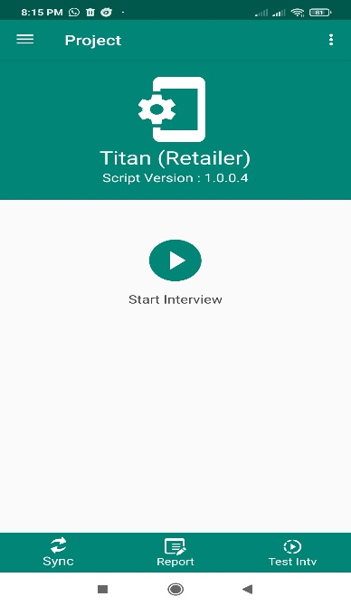
- You are now ready to start an interview from this page. Click on the
Start Interview button to start an interview. You can also do the test
interview using Test Intv button. To sync the interview one by one we
need to click Sync button and Report button is used to get the field
report for this individual tab.

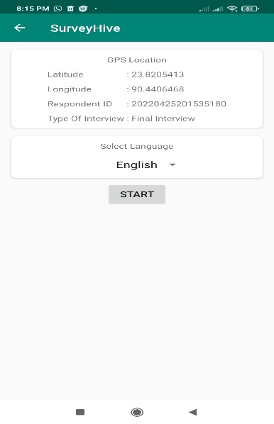
- After clicking Start Interview button a page will appear with GEO
location and language selection option. For Bangla select Bangla and
for English select English for this dropdown menu. You can also select
your specified language if that language was incorporated in script.

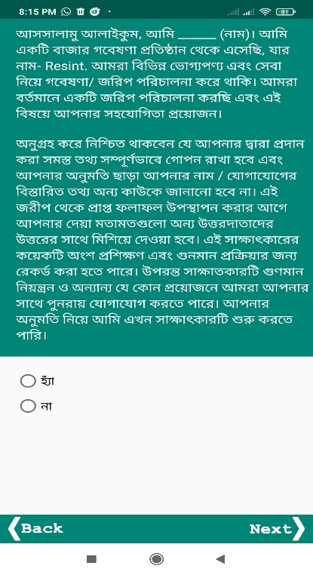
- Click “Start” Button to go ahead and start the interview.
After taking the response press “Next>” button to go
next question.

- Back button of mobile/tab is used to pause/terminate the
interview otherwise please don’t use the back button of
mobile/tab.

- The script will take you the end of the interview automatically.
And at the end of the interview, it will show “Finish” button in
place of “Next” button. And click it to finish the interview.

How to sync successful Interview
- To sync successful interviews, click on the Sync button on project page and it will show you the successful interview list. Select one interview by click on the list and then click right corner sync button to sync the selected interview to server. After successful sync the synced interview will be removed from list.
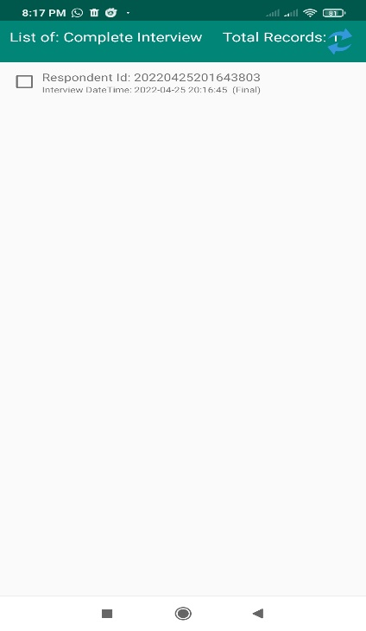
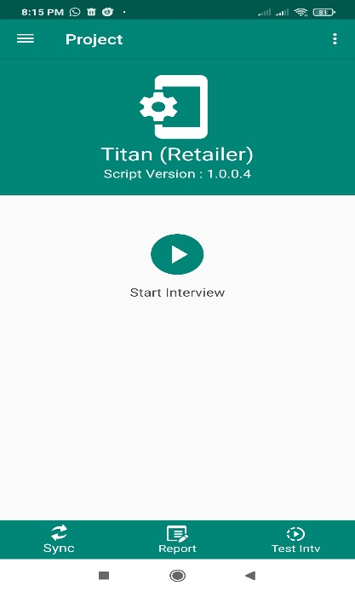

How to start incomplete interview
- If any interview remains paused / incomplete we can resume that interview. To do so click left corner menu icon and then click resume interview. It will take you the incomplete interview list page. Click on the right button of a list will take you to the question where you paused of main interview.
